AP Human Geography
“(AP)” = From released AP exams. (Most likely to be on exam.)
“(MM)”=Most Missed (+25% of students missed this question)
Chapter 2 Practice Exam: Population and Health (2018/v.1)

- (AP) Traditionally, the Ganges Valley and the Nile Valley have had comparatively high population densities because of their
  - tropical climate
  - heavy industrialization
  - in-migration from neighboring and areas
  - intensive agriculture based on irrigation
  - designation as sacred sites

- (AP) Prior to 1850 the location of all major North American cities was related, chiefly, to the presence of
  - transcontinental highways
  - defensive sites
  - railroad junctions
  - navigable waterways
  - water power

- (AP) Why are most South American population centers located at or near the coast?
  - The colonial economies were export-oriented.
  - The wars of independence damaged many
inland cities.
  - Few Amerindian population centers were
located on the coast.
  - Latin American armed forces have extensive
plans for the defense of coastal sites.
  - The climate is generally warmer on the coast
and cooler in the highlands.

- (AP) Of the following, which region contains the smallest percentage of the world’s population?
  - The Southern Hemisphere
  - The Northern Hemisphere
  - The Eastern Hemisphere
  - Coastal areas of the world within 160 kilometers (100 miles) of ocean
  - Areas of the world lying lower than 150 meters (500 feet) above sea level

- (AP)(MM) Which of the following regions had the smallest percentage of people living in urban areas at the end of the twentieth century?
  - Australia
  - South Asia
  - North America
  - Europe
  - South America

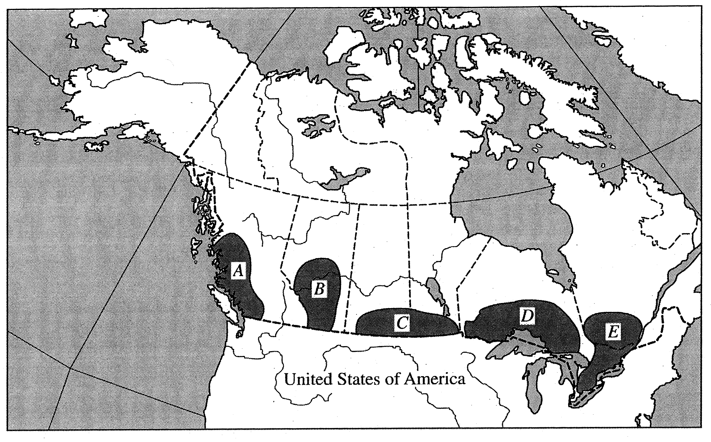

- (AP) On the map above, which letter represents the region of the greatest proportion of the Canadian population?
  - A
Review population agglomerations for: US, Canada, Mexico, China, India, Europe, S. America, and Africa
  - B
  - C
  - D
  - E

- (AP) Physiological population density differs from crude population density in that physiological density
  - examines only the population of cities, while crude density includes the population of cities and rural areas
  - is a measure of how density is perceived, while crude density is a measure of specific density
  - explains density in terms of people per arable square land unit, while crude density explains density in terms of people per total square land unit
  - explains the density of a single housing unit while crude density explains the density of a group of houses
  - is the number of people per housing unit, while crude density is the number of people per square mile

- (AP) Sri Lanka and Australia have about the same population. What data would help you determine which country has a higher physiological population density?
  - The area of each country
  - The number of farmers in each country
  - The total fertility rate of each country
  - The amount of arid land in each country
  - The amount of arable land in each country

- (AP) Of the following countries, which has the fewest people per unit of arable land?
  - Guatemala
  - Bangladesh
  - Argentina
  - Netherlands
  - Egypt
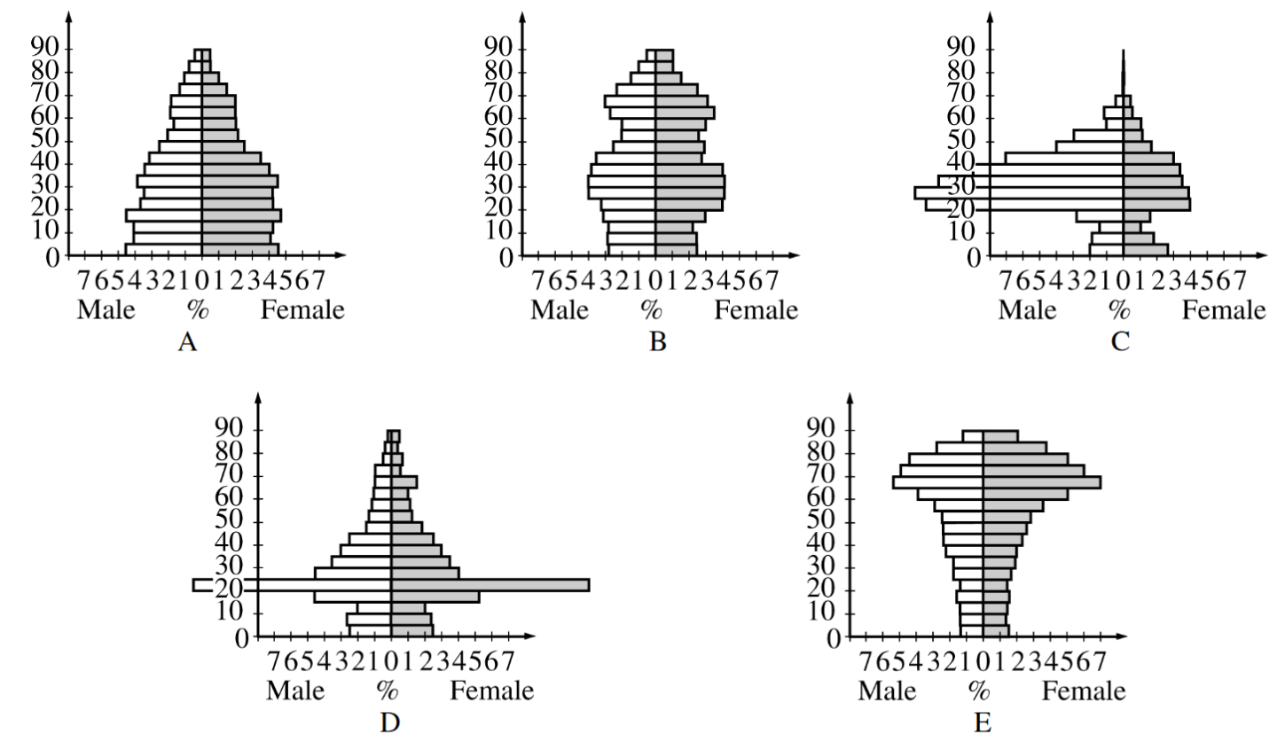
- (AP) Which population pyramid shown above best represents a college town?
  - A
  - B
  - C
  - D
  - E

- (AP)(MM) Which population pyramid shown above depicts the largest dependency ratio.
  - A
  - B
  - C
  - D
  - E

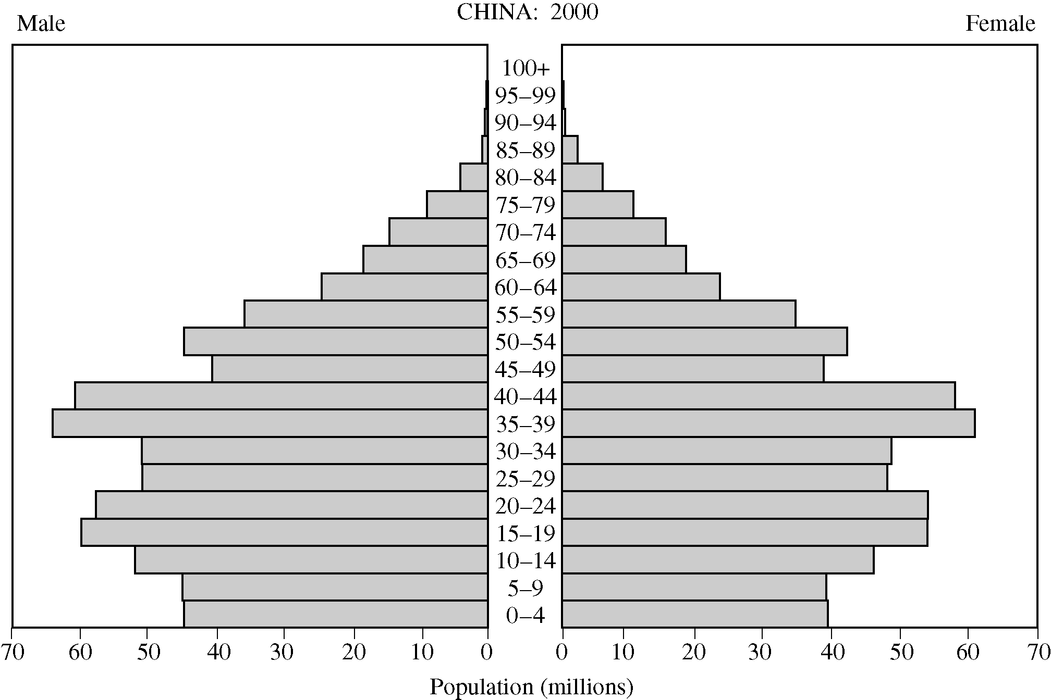

- (AP) Based on the population pyramid above, which of the following will pose the greatest demographic challenge to China beginning in 2029?
  - Providing for the needs of its aging population
  - Finding enough teachers to educate the young
  - Limiting out-migration of the 60- to 64-year-old age cohort
  - Providing prenatal medical care
  - Controlling population growth

- (AP) The measure of the average number of children who are born to women of childbearing age (15-45) in the population is called the
  - actual birth rate
  - crude birth rate
  - total fertility rate
  - adjusted birth rate
  - net reproduction ratio

- (AP) In the first decade of the twenty-first century, which of the following countries had the lowest fertility rate?
  - Somalia
  - Niger
  - Angola
  - Democratic Republic of Congo
  - South Africa

- (AP) In which of the following pairs do both countries exhibit zero or negative population growth rates?
  - Pakistan and China
  - India and Germany
  - Japan and Germany
  - China and India
  - India and Japan

- (AP) Which of the following characteristics is currently shared by Switzerland, Canada, and New Zealand?
  - Low population-growth rates
  - Primate urban systems
  - High infant-mortality rates
  - Membership in the European Union (EU)
  - More than ten percent of the population involved in sheep farming

- (AP) Which of the following characteristics applies to more-developed countries?
  - Early stages of epidemiological transition
  - Long life expectancies
  - High total fertility rates
  - Rapid population growth
  - Early stages of the demographic transition

- (AP) Which statement best describes population growth patterns in the world today?
  - In the world as a whole, women have an average of five or more children, leading to Malthusian crises.
  - Fertility rates in low- and middle-income countries worldwide are higher now than 25 years ago.
  - In the world as a whole, fertility rates have fallen in the last 25 years.
  - In sub-Saharan Africa, South Asia, and the Pacific, fertility rates have doubled in the last 25 years.
  - Fertility rates in most high-income countries have risen in the last 25 years.

- (AP) Which of the following is a correct statement about the demographic transition model?
  - It is applicable only to eighteenth-century Europe.
  - It predicts the growth of population in Russia reasonably well.
  - It divides the demographic changes of a country into two stages of slow growth and high growth.
  - It supports the idea that technology can remove or extend the limits of food production.
  - It is characterized by relatively low growth rates at stage 1 and stage 4.

- (AP) A country in the first stage of the demographic transition demonstrates which of the following?
  - An old population age structure
  - High birth rates, but low death rates
  - Low birth rates, low death rates, and low rates of population growth
  - High birth rates, high death rates, and low rates of population growth
  - High birth rates, high death rates, and high rates of population growth

- (AP) Even though total fertility rates have been declining in some less-developed countries, the total population has continued to grow. This is primarily because a high percentage of the population is
  - female
  - male
  - over the age of 15
  - under the age of 15
  - receiving adequate medical care

- (AP) The term that describes the concept that population will continue to grow even after fertility rates decline is known as
  - demographic momentum
  - demographic transition
  - rate of natural increase
  - the population pyramid
  - the homeostatic plateau

- (AP) The dependency ratio is most useful for indicating the
  - reliance of a country on imported fossil fuels
  - degree of gender equality within a country
  - relationship between the total fertility rate and the infant mortality rate
  - percentage of foreign ownership within the secondary sector of a country’s economy
  - relationship between the potential labor force and the remainder of a country’s population

- (AP) Which factor is most responsible for the increase in Japan’s dependency ratio?
  - An increase in life expectancy
  - An increase in the death rate
  - An increase in the rate of natural increase
  - A decrease in the doubling time
  - An increase in the total fertility rate

- (AP) The Malthusian view of the world argues that
  - the contemporary problem of famine in developing countries is a result of the colonial legacy
  - the problem of population growth is a result of economic underdevelopment
  - one way to solve population growth in developing countries is to reduce their foreign debt
  - famine in developing countries can be explained by examining their patterns of population growth
  - population growth is helpful to developing countries because it provides a larger rural workforce

- (AP) Thomas Malthus based his work on population on which of the following premises?
  - Both food production and population increase arithmetically .
  - Food production increases arithmetically and population increases exponentially .
  - Both food production and population increase exponentially .
  - Food production increases exponentially and population increases arithmetically .
  - Food production increases arithmetically and population remains stable

- Demography is
  - the study of the relationship between government and population.
  - the study of population.
  - the study of population growth.
  - the mapping of population characteristics.
  - none of the above

- The part of Earth’s surface that is physically suitable for permanent human settlement is known as
  - the ecumene.
  - the ecosystem.
  - the ecosphere.
  - the biosphere.
  - the biosystem.

- Human beings avoid clustering in ALL BUT WHICH of these lands?
  - cold lands
  - dry lands
  - wet lands
  - hot lands
  - highland regions

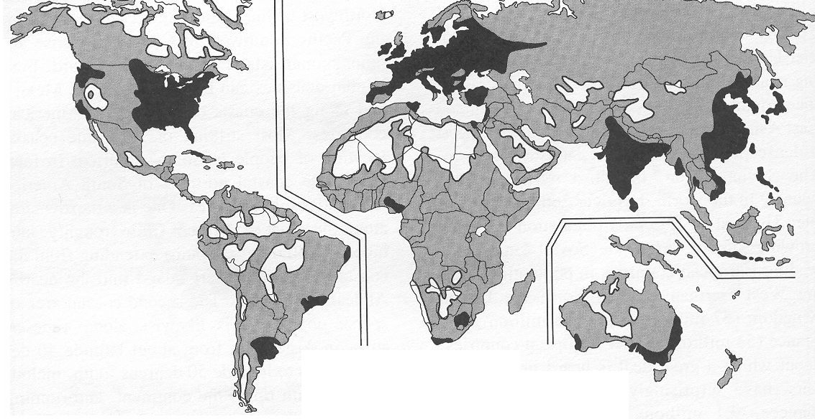

- On the map above, the lightest portions show
  - arithmetic density
  - ecumene
  - population cluster
  - population concentration
  - non-ecumene

- Which of the following statements is FALSE concerning the world's population?
  - Uneducated women usually have higher fertility rates.
  - Population growth rates differ from place to place.
  - Population is evenly distributed over the earth's surface.
  - High fertility rates tend to be in overpopulated areas.
  - Artificial birth control use is higher in core countries.

- Two-thirds of the world's population is clustered in four regions. Which of the following is NOT one of these four regions?
  - East Asia
  - Southeast Asia
  - Sub-Saharan Africa
  - Europe
  - South Asia

- (MM) Global patterns that are affected by population issues are concentrated in __________, where 2/3rds of the world's population lives.
  - Southeast Asia and India
  - Europe and Asia
  - China and India
  - Northwest Europe and South Asia
  - Europe and China

- Population in East Asia declines from:
  - south to north
  - north to south
  - the interior toward the coast
  - the coast toward the interior
  - northern coast to southern coast

- While most of the countries in East Asia are highly urbanized, one still has over 40% of its population living in rural areas. Which is it?
  - Japan
  - China
  - South Korea
  - Taiwan
  - Bangladesh
- The largest population cluster in the Western hemisphere is in the
  - Southwestern United States and Southeastern Canada
  - Southern United States and Northeastern Canada
  - Northeastern United States and Northeastern Canada
  - Northwestern United States and Northeastern Canada
  - Northeastern United States and Southeastern Canada

- China and India are important in studying future population growth because together they represent _____ percent of the world’s population.
  - 5
  - 10
  - 15
  - 35
  - 50

- Which of the following is NOT among the most populous countries of the world today?
  - Argentina
  - Pakistan
  - Indonesia
  - United States
  - Bangladesh

- A population concentration (cluster) is today emerging in Africa focused on
  - Eastern coastal region
  - South Africa
  - Nigeria and coastal West Africa
  - North Africa
  - Central Africa

- The major focus of Algeria's population is
  - the Sahara.
  - the south.
  - the north.
  - along the Atlantic Coast.

- Which of the following regions has the highest percentage of people living in cities (highest urbanization rate)?
  - East Asia
  - South Asia
  - Europe
  - South America
  - Sub-Saharan Africa

- Dividing a country's population by its total land area gives a geographer what statistic?
  - Physiologic density
  - Arithmetic density
  - Spatial density
  - Clustered density
  - Agglomerated density

- Which of the following countries has the lowest arithmetic density?
  - Brazil.
  - United States.
  - United Kingdom.
  - Canada
  - India.

- The problem with using arithmetic population density to investigate the population pattern of a country is that such a density figure does not take into consideration:
  - annual population increases
  - internal clustering patterns
  - annexation of new territory
  - possible loss of territory
  - external political forces

- Physiological density is the number of
  - acres of farmland per city
  - farmers per area of arable land
  - people per area of land
  - people per area of arable land
  - people per farmer

- If the physiological density is much higher than the arithmetic density, then a country probably has:
  - inefficient farmers
  - a large number of farmers
  - a small percentage of arable land
  - a difficult time feeding its own people
  - a very large population overall

- (MM) India and the United Kingdom have approximately the same agricultural density. From this we can conclude that the two countries have the same
  - level of output per farmer.
  - number of people per area of land.
  - pressure placed by people on the land to produce food.
  - number of farmers per area of land.
  - all of the above

- Historically, the world’s population grew
  - very steadily from 1000 CE until the present.
  - slowly until about 1800 CE, before growing quickly between 1800 CE and the present.
  - quickly until about 1800 CE, before slowing down between 1800 CE and the present.
  - slowly until about 1000 CE, before growing quickly between 1000 CE and the present.
  - quickly until about 1000 CE, before declining between 1800 CE and the present.

- The Natural Increase Rate (NIR) of a population can be defined as
  - the estimated number of children born to each father during a one-year period
  - the difference between crude birth rates and crude death rates divided by 10
  - the estimated number of children born to each female during their reproductive years (ages 15-45)
  - the total number of children each female given birth in the previous ten-year period
  - the number of children per family required to replace the previous generation

- "Doubling time" or the number of years required for a population to double in size can be estimated by
  - dividing the total population by the Total Fertility Rate
  - counting back the number of years to when the population was half the current size
  - multiplying the Total Fertility Rate by the Rate of Natural Increase
  - dividing 70 by the Rate of Natural Increase
  - multiplying the Rate of Natural Increase by the Total Life Expectancy

- Today, world population doubling time is
  - 300 years
  - increasing (i.e. taking longer to double)
  - decreasing (i.e. taking less time to double)
  - ten years

- A decline in a country’s crude birth rate would result in an increase in the country’s
  - total fertility rate
  - life expectancy
  - crude death rate
  - doubling time
  - infant mortality rate

- The Natural Increase Rate of the world during the early 21st century has been:
  - 4 percent
  - 2.2 percent
  - .5 percent
  - 1.2 percent

- At the present rate of births and deaths in the world, we are adding about _____ million inhabitants every year.
  - 50
  - 10
  - 80
  - 250

- Presently, about 98% of growth in the world's population is occurring
  - in Western countries.
  - in More Developed Countries (MDCs).
  - in Less Developed Countries (LDCs).
  - in Africa
  - in the Western Hemisphere.
- The principal reason for declining natural increase rates in less developed countries today is
  - increasing crude birth rates.
  - declining crude birth rates.
  - increasing crude death rates.
  - declining crude death rates.
  - balanced natural increase rates.

- Which area of the world is experiencing the most rapid population growth?
  - East Asia
  - South Asia
  - Central Europe
  - Sub-Saharan Africa
  - South America

- Which country will likely increase its percentage of the world's population the most in the next 20 years?
  - China
  - India
  - Nigeria
  - United Kingdom
  - United States

- The highest Crude Birth Rates (CBR) in the world are found in
  - Latin America
  - Middle East.
  - China
  - Sub-Saharan Africa
  - Europe.

- (MM) Of the following countries, the lowest crude birth rate (CBR) would likely be found in
  - Mexico
On the exam, the answer to this question will be one of these very low CBR countries: Japan, Croatia, Estonia, Ukraine, Germany, Italy, Spain, Portugal, Greece
  - Argentina
  - Spain
  - Ethiopia
  - India

- How can a country or region slow down its birth rates?
  - Keep girls in school longer.
  - Improve economic opportunities for women
  - Distribute birth control devices.
  - Reduce infant and child mortality.
  - All of the above.

- Almost everywhere on Earth, Total Fertility Rates (TFRs)
  - are rising.
  - are falling.
  - are staying about the same.
  - are influenced by precipitation levels.

- (MM) Excluding migration, a country or region will achieve ZPG (zero population growth) when it has
  - a crude birth rate of 1.0
  - the crude death rate exceeds the crude birth rate
  - a life expectancy is high and infant mortality is low
  - a total fertility rate of 2.1
  - a total fertility rate of 0

- The Total Fertility Rate of the United States for 2008 was estimated to be 2.1. What does this mean for the population of the United States?
  - The doubling time of the United States is about 35 years.
  - The United States is experiencing rapid natural increase.
  - All population growth in the United States is due to migration and not natural increase.
  - The United States will experience population decline in the next 30 years.
  - All of the above.

- Efforts to lower CBR through improved education and health care for women have shown statistically to result in all but which of the following?
  - Improvement in prenatal care results in reduced infant mortality rates.
  - With the survival of more infants secure, women are more likely to use contraceptives to limit pregnancies.
  - With improved education, women are more aware of reproductive rights and make more informed reproductive decisions.
  - With greater education women have an improved opportunities and are less likely to see children as necessary labor and social security.
  - Men take on the burden of contraception.

- For every 1,000 babies born in Mozambique this year, nearly 150 of them will die before they reach their first birthday! The rate of 150 deaths per 1,000 births is known as the
  - crude death rate
  - infant mortality rate
  - life expectancy
  - total fertility rate
  - dependency rate

- In which region are the highest rates of infant mortality found?
  - South America
  - Sub-Saharan Africa
  - East Asia
  - Eastern Europe

- The number of deaths per 1000 population between the first and fifth birthdays is known as:
  - natural increase rate
  - infant mortality rate
  - crude death rate
  - total death rate
  - child mortality rate

- The highest rates of all of the following demographic measures are typically found in LDCs (less developed countries) EXCEPT?
  - crude birth rates
  - crude death rates
  - infant mortality rates
  - natural increase rates
  - total fertility rates

- In studying population growth and attempting to predict future patterns of growth, geographers most frequently refer to the
  - dependency ratio
  - crude death rate
  - infant mortality rate
  - current rate of natural increase
  - total fertility rate

- Life expectancy is lowest on average in
  - Sub-Saharan Africa.
  - East Asia.
  - North America.
  - Europe.
  - Southeast Asia.

- Improvements in health care systems, sanitation, infrastructure and personal nutrition are factors that lead to
  - increased total fertility rates and higher birth rates
  - increased birth rates and decreased life expectancy
  - decreased life expectancy and increased total fertility rates
  - increased infant mortality rates and increased total fertility rates
  - decreased infant mortality rates and increased life expectancy

- The highest crude death rates are found in countries in which stage of the demographic transition?
  - Stage 1
  - Stage 2
  - Stage 3
  - Stage 4
  - Stage 5

- The Industrial Revolution caused countries to move into what stage of the demographic transition?
  - stage 1
  - stage 2
  - stage 3
  - stage 4

- Country X has a crude birth rate of 40 and a crude death rate of 15. In what stage of the demographic transition is this country?
  - Stage 1
  - Stage 2
  - Stage 3
  - Stage 4
  - Stage 5

- In contrast to the experience of relatively developed countries, developing countries entered Stage 2 of the demographic transition through
  - creation of higher levels of wealth
  - gradual diffusion of the industrial revolution
  - sudden injection of medical technology from developed nations
  - changes in their economic and social systems
  - the Industrial Revolution

- In the demographic transition model the point where NIR (population growth rate) would be at its highest rate would be
  - the beginning of Stage 1
  - the end of Stage 4
  - the line between Stage 1 and Stage 2
  - the line between Stage 2 and Stage 3
  - the line between Stage 3 and Stage 4

- Which of the following is most characteristic of societies currently in the last stage of demographic transition?
  - Hyperinflation
  - Unemployment
  - Youth dependency
  - Aging population
  - Overpopulation

- As shown in Stage 4 of the Demographic Transition model, birth rates can dip below death rates. A country that would be an example of this phenomenon would be
  - Italy
  - Mexico
  - Brazil
  - United States
  - India

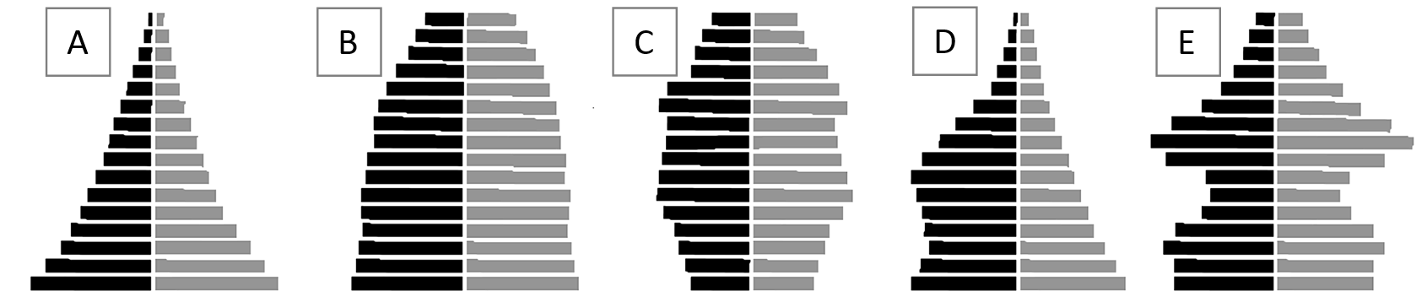

Use the population pyramids above to answer the questions 80-82. The male population is on the left of each pyramid. The female population is represented is on the right.

- Which population pyramid best reflects the population structure of a rapidly growing stage 2 country like Angola (or some other Sub-Saharan African country)?
  - Pyramid “A”.
  - Pyramid “B”.
  - Pyramid “C”.
  - Pyramid “D”.
  - Pyramid “E”.

- Which population pyramid shows a population that is slowly growing stage 3 country like Mexico?
  - Pyramid “A”.
  - Pyramid “B”.
  - Pyramid “C”.
  - Pyramid “D”.
  - Pyramid “E”.

- Which population pyramid shows a population whose stage 4 country like Germany whose population is slowly declining?
  - Pyramid “A”.
  - Pyramid “B”.
  - Pyramid “C”.
  - Pyramid “D”.
  - Pyramid “E”.

- The stages of the epidemiologic transition are based on
  - causes of death at varying stages of the demographic transition.
  - the means through which disease is transmitted spatially.
  - non-contagious diseases such as heart disease, obesity, or diabetes.
  - pandemics like the bubonic plague, influenza, or AIDS.

- Cancers and heart disease are most common in countries in which stages of the epidemiologic transition?
  - 1 and 2
  - 2 and 3
  - 3 and 4
  - 1 and 4

- Stage five of the epidemiological transition is the stage of
  - pestilence and famine.
  - receding pandemics.
  - degenerative and human created diseases.
  - delayed degenerative diseases.
  - reemergence of infectious and parasitic diseases.

- Which of the following is NOT a reason for a potential future stage five of the epidemiological transition model?
  - poverty in LDCs makes sanitation and medical improvement unaffordable
  - high infant mortality
  - evolution of microbes
  - international travel

- A population pyramid
  - shows the age and sex structure of a population.
  - cannot be used to compare two different countries.
  - demonstrates the demographic transition model.
  - only accurately depicts declining populations.
  - is most useful in illustrating social upheaval.

- Which of the following differences between two populations could NOT be discerned by comparing their population pyramids?
  - sex ratios
  - dependency ratios
  - population densities
  - crude birth rates
  - life expectancies

- One would expect to find a population with a relatively young age structure in
Hint: C, D, and E are characteristic of MDCs.
  - less developed countries
  - highly developed countries
  - countries with a low death rate
  - countries with a low fertility rate
  - countries with a high standard of living

- Reasons why women in the United States are having fewer children than 50 years ago include all of the following except
  - women are getting married later in life.
  - women are becoming more educated
  - women are more likely to enter the work-force.
  - women have poorer diets.
  - women are more likely to use contraceptives.

- In comparing Malthus's theory to actual world food production and population growth during the past half-century, the principal difference is that
  - Largely because of the Green Revolution, actual food production has been higher than Malthus predicted.
  - Malthus's theory predicted much higher food production than has actually occurred.
  - Actual population growth has been much higher than Malthus predicted.
  - Malthus's theory predicted much higher population growth than has actually occurred.

- (MM) Neo-Malthusians argue that
  - in addition to outstripping food supply, world population growth is also overtaxing other resources like energy, arable land, and clean water.
  - Governments should discourage population growth because industrial growth is slowing in the developed countries.
  - population growth in Least Developed Countries (LDCs) will end as the population in those countries becomes more educateD
  - More Developed Countries (MDCs) will experience a population crash due to the aging of their populations.
  - none of the above.

- Which statement about overpopulation is true?
  - Overpopulation is unlikely because food production potential is unlimited
  - Overpopulation occurs when an area’s population is greater than its carrying capacity.
  - Overpopulation can only occur in less-developed areas.
  - Overpopulation is achieved when the physiological density reaches more than 1,000/km.
  - All of the above.

- The ability of a resource base to sustain a population is known as its
  - support ratio
  - carrying capacity
  - subsistence limit
  - basic employment
  - population pressure

- Areas in the Saharan desert region of Africa possess a low
  - carrying capacity.
  - birth rate.
  - death rate.
  - transhumance.
  - total fertility rate

- Pro-natalism is
  - a governmental policy that discourages its population to have more children.
  - a government policy that encourages zero population growth.
  - a government policy that encourages growth through migration.
  - a government policy that encourages its population to have more children.
  - none of the above

- (MM) The long-term demographic effect of the One-Child Policy in China has been
  - large-scale out-migration of Chinese to foreign countries
  - reduction of the total fertility rate below the replacement rate
  - mass rural to urban migration smaller total population of China
  - in-migration of foreign guest workers to fill low-paying service jobs

- The low rate of contraceptive use by women in Sub-Saharan Africa reflects
  - spousal disapproval (husbands say no)
  - cultural and religious opposition
  - difficulty in reaching rural areas (distance barriers)
  - inadequate education/information
  - all of the above

- An anti-natalist population policy
  - is meant to lower the infant mortality rate.
  - is meant to raise the Total Fertility Rate (TFR) of the population.
  - is meant to lower the Total Fertility Rate (TFR) of the population.
  - encourages population growth.
  - discourages the use of birth control.

- The strongest pro-natalist policy is likely to be found in which of the following countries?
  - Italy
  - India
  - United States
  - China
  - Afghanistan

